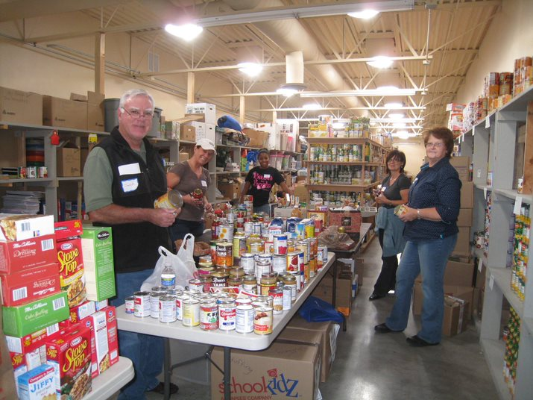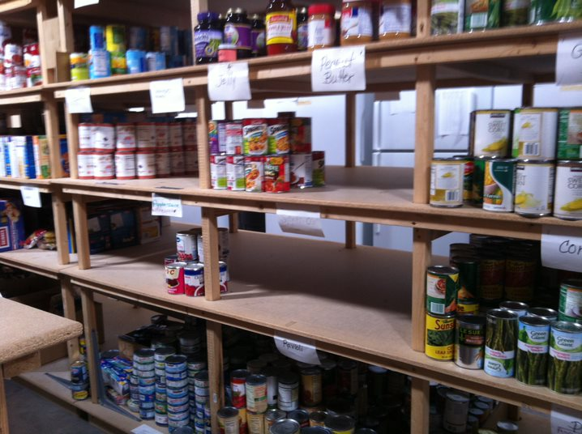

CanNED Food Drive
Tri-Lakes Cares
---------------------------------------------------------------------
We Need Your Help!

My name is (your name here) and I am teaming up with Tri-Lakes Cares to help stock our Food Pantry in order to serve our community better!!
Items We Need:
- Canned Vegetables
- Cereal
- Chicken Broth
- Chili
Each month over 1,900 individuals receive assistance from one of our food programs here at Tri-Lakes Cares. The food programs we offer our clients help defeat hunger in our community. We would love for you to be a part of what we do here! Please donate any of the items listed above by placing them on your porch and attaching this flyer by the designated pick-up day!!
Pick-up Date: 4/17/2020 Pick-up By: (your name here)

